Electronics Documentation

1. Electronics Block Diagram
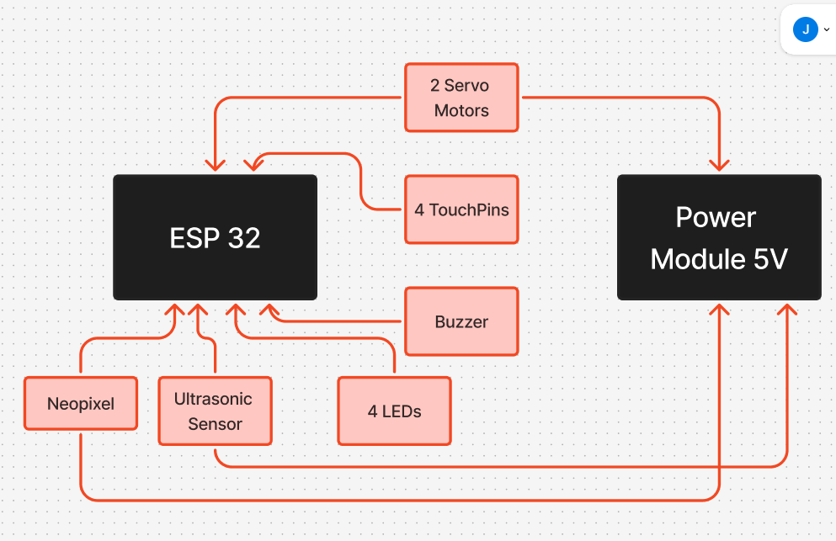

2. Components Table
Component | Quantity | Purpose | Justification
ESP32 Microcontroller | 1 | Main controller for game logic, WiFi server, and hardware control | Supports WiFi + touch inputs + PWM in one board and ideal for interactive installations
Ultrasonic Sensor (HC-SR04) | 1 | Detects player presence to start the game | Enables touchless interaction and immersive “approach to start” experience
Capacitive Touch Wires (Touch Pins) | 4 | User input for answering questions (A/B/C/D) | Touch sensors make the game easy and fun to control with just a touch, making the game more simple and interactive
LEDs | 4 | Visual progress indicator for game stages | Provides immediate feedback; mapping 2 questions per LED makes progression intuitive and guide the player to the right next step
Servo Motor (Door Mechanism) | 1 | Opens the door when player wins | Adds physical reward or output to the game, making the experience tangible and satisfying
Servo Motor (Sphinx Head) | 1 | Moves head for feedback on wrong answers | Enhances storytelling and personality of the system
Buzzer | 1 | Audio feedback for correct/wrong answers | Reinforces feedback through sound, improves user engagement
NeoPixel LED | 1(16 LEDS) | Ambient lighting and feedback effects | Enables visual feedback for the player
Power Module(5V) | 1 | Powers ESP32 and components | Power required for servo + LEDs to function properly

